**Project Report Template**

1. **INTRODUCTION**
   1. **Overview**

Vehicle management system is software which is helpful for bus operators, who wants to operators many bus trips in a day

* 1. **Purpose**

Assist in the tracking of vehicle operation and the planning of maintenance

**2** **Problem Definition & Design Thinking**

**2.1 Empathy Map**

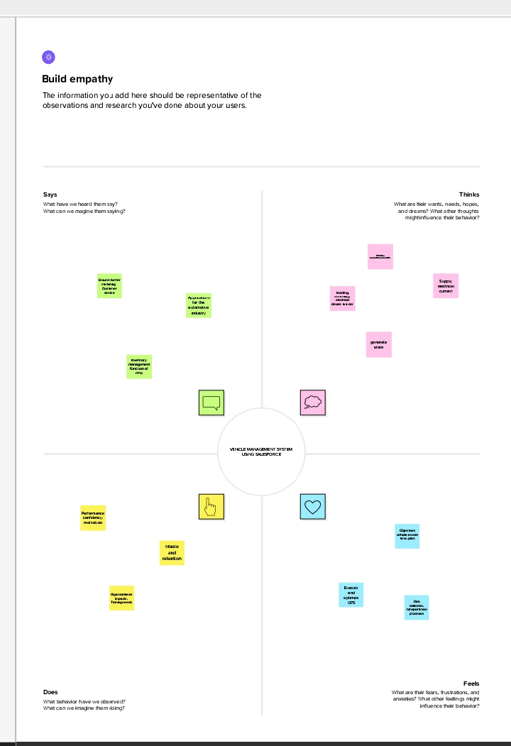

**2.2 Ideation & Brainstorming Map**.

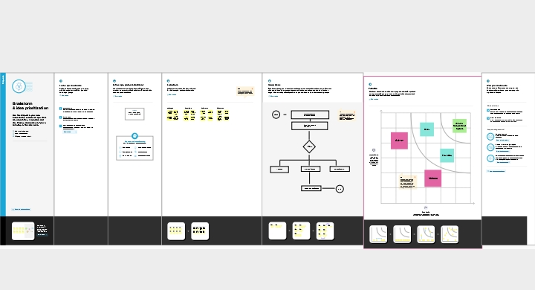

1. **RESULT**

**3.1 Data Model**:

|  |  |  |  |  |  |  |
| --- | --- | --- | --- | --- | --- | --- |
| Object name | |  | | --- | | Fields in the Object | | Field label | | |  | | --- | |  | | Data type | |
| Semester | student | Students |
| Candidate | Internal Result  Card | Internal Result  Card |
| Course Details | Course Name | Course Id |

**3.2 Activity & Screenshot**

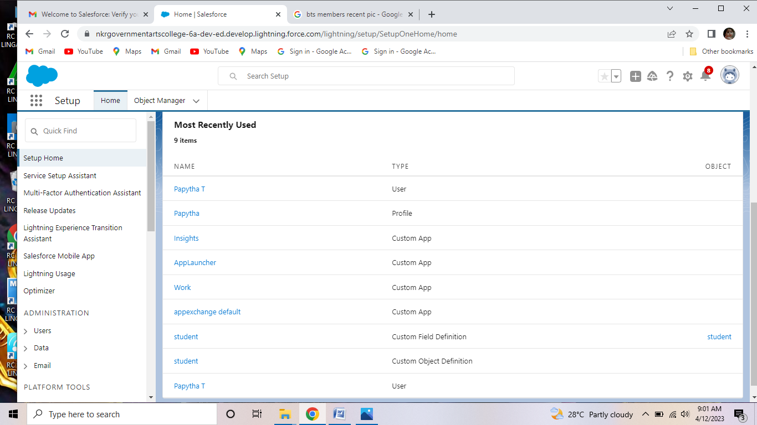

**4 Trailhead Profile Public URL**

**Team Lead**

Papytha T : <https://trailblazer.me/id/papy2>

**Team Member**

Manjusri R : <https://trailblazer.me/id/manjusri>

Ponmani S : <https://trailblazer.me/id/pponmani>

Poornima P: <https://trailblazer.me/id/pphytmshift2>

**Project Report Template**

**5 ADVANTAGES & DISADVANTAGE**

List of advantages and disadvantage of the proposed solution

6 **APPLICATION**

The areas where this solution can be applied

**7 CONCLUSION**

Conclusion summarizing the entire work and findings.

**8 FUTURE SCOPE**

Enhancements that can be made in the future.